**Web Principles**

Portfolio website implementation and design report

**22026940**

**Umar Shan Arif**

M.Sc. Computer Science

Table of Contents

Table of Figures: 3

1. Web Principles 4

1.1. Web Design Types 4

1.1.1. Static Pages Website 4

1.1.2. Single Page Website 4

1.1.3. Dynamic Website 4

1.1.4. Responsive Website 4

1.1.5. Liquid Website 5

2. Umar Shan’s Portfolio Design 5

2.1. Designs Applied 5

2.2. HTML Validation 5

2.3. Best Web Principles Followed 6

2.3.1. Simplicity 6

2.3.2. Responsiveness 6

2.3.3. Navigation 6

2.3.4. Load Time 6

2.3.5. Coherence 6

2.4. Browser Compatibility 7

2.4.1. Browser Compatibility Test 7

3. Web Standards 8

3.1. Web Standards on Components 8

3.1.1. Images, Graphics and Illustrations 8

3.1.2. HTML, CSS and JavaScript 8

3.1.3. Impact on Users 8

3.1.4. Impact on Developers 8

4. Low Fidelity design 9

5. Activity Diagrams 15

References 17

# Table of Figures:

Figure 1: Home Page 8

Figure 2: About Page 8

Figure 3: Academic and Professional Experience 9

Figure 4: Services and Skills page 9

Figure 5: Contact Page 10

Figure 6: Portfolio Page 10

Figure 7: Mobile View About Page 11

Figure 8: Mobile View Home Page 11

Figure 9: Mobile View Experience Page 12

Figure 10: Mobile View Education Page 12

Figure 11: Mobile View Navigation 13

Figure 12: Mobile View Contact Page 13

Figure 13: Activity Diagram Currency Converter 14

Figure 14: Activity Diagram Fuel Cost Forecaster 15

# Web Principles

Wide usage of websites is leading to many different problems/disadvantages. Web-based applications have gained popularity and higher users base as a result of increase of web apps useability, security, fast load time and low maintenance costs. There has been a lot of progress in web development lately. As result of these advancements web developers should consider few factors including but not limited to design consistency, graphics, typography, colors, user experience, and functionality. Web developers must practice good principles while developing websites. Each website has its own primary/intended user-base and functionalities, developers must consider the users’ and business domain during the development.

## Web Design Types

Website design is one of the key factors which affects the traffic of a website. Website designs have been evolving since 1900s. Design improvements aims to improve a website’s readability, useability. There’s no good design type which suits to website purpose. Below are some briefly explained web designs

### Static Pages Website

The very basic website design type is static page website. This design has pre-defined page dimensions, static width regardless of device type or browser. While static layouts are still an option, you typically don`t want to use them unless you`re creating a separate version of your site for mobile devices.

### Single Page Website

This website design type has single-page layout, user uses scroll to discover information about services and products. You can use navigation menu with links to different sections of page. Most portfolio websites follow single page designs.

### Dynamic Website

Dynamic websites server opposite of static websites. User interaction the primary functionality of dynamic websites. Dynamic websites can deliver different content to a visitor, even if two separate people look at the same page. These websites require a server and server-side language like JavaScript, PHP and ASP. This design type is followed in most Ecommerce websites.

### Responsive Website

The most widely used website design which allows developers to create websites which accommodates its content all screen sizes perfectly. This design follows mobile-first approach. The cross-screen compatibility make this design most popular and widely used design.

### Liquid Website

Liquid design is also known as fluid design, its uses flexible unit. As units are flexible in nature page always fills the screen width, regardless of the type of device.

# Umar Shan’s Portfolio Design

My portfolio website follows a hybrid design by combining static design, responsive design, and single page website design. Portfolio is implemented by using Hyper text markup language (HTML), cascading style sheet (CSS) and JavaScript (scripting language).

## Designs Applied

A well-designed website that considers one of the crucial web principles such as usability is vital, and proof shows high visitor retention and purchasing behavior (Avouris, et al., 2003). My portfolio is using responsive design to make all content have same presentation on all sized devices, home page, about page, skills and portfolio pages are following additionally static design as content is static. Tasks pages are interactive and content changes on users interaction both tasks pages are following dynamic web design in addition to responsive design.

## HTML Validation

HTML validation is process of verifying the markup document, in given case the HTML file which renders my portfolio. I’ve used W3C markup validation to verify the validate my HTML code. Attached is the result of my portfolio mark up validation. W3C is one of the most popular HTML validators, these services scan the html documents and ensures proper syntax and document version are followed.

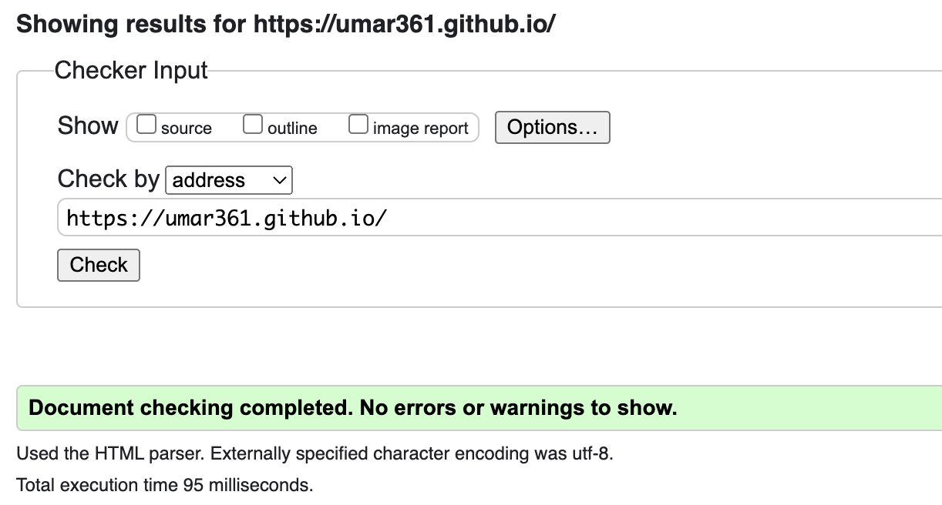

## Best Web Principles Followed

A good website is created by following best practices only, these practices are briefly explained here:

## Simplicity

Keeping website content as simple to fit the purpose is the key to high useability, higher traffic engagement and users’ retention. Simplicity encourages the best user experience by reducing un-necessary content and navigation/action to perform a task. Simplicity is very well adopted in my portfolio.

## Responsiveness

Nowadays its common to access all websites on mobile phones. As of 2021 stats United Kingdom has 53 million of active mobile phone users which is 80% of United Kingdom population. Responsiveness makes websites accessible to the most of users. My portfolio is responsiveness and can be view perfectly on any screen size.

## Navigation

Navigation in a website enables user to move around different sections of website and find the information or perform the actions they are looking for. Easy navigation is key to user experience and user retention. My portfolio is a single page website, I’ve added navigation make user journey easier to find the section they are interested in.

## Load Time

Nobody loves getting response from someone after ages. Load time of a website is the response time to its users. A good website must have the most least load time to retain the users, users won’t use high load time website. My portfolio is hosted on github pages which have most lowest load time and code and resources are optimized to have least load time.

## Coherence

Every business/website has a unique personality, as an entity. That personality demonstrates the history, services, and mission of business. Communicating the unique qualities of a business involves making every element of a website to reflect the business personality. Every piece must fit seamlessly to create a coherent appearance of the brand. All typography, color and imagery must reflect the brand/business personality. My Portfolio has been made coherent making sure all elements are communicating a single theme/personality.

## Browser Compatibility

With increasing number of web browsers, developers must take in consideration how their websites will be presented to each user using different web browsers with different engines. Each browser differently interprets code before presenting your website to users. It’s never easy to handle all browsers compatibility but it’s worth making your website accessible to all users. Following are practices we can use to make websites browser compatible:

## Browser Compatibility Test

1. Continues testing
2. Writing platform independent code
3. Use browser testing tools, like Browserstack, LambdaTest, BrowserLing, etc.

# Web Standards

Web standards are recognized non-proprietary standards and other technical definitions that articulate and describe aspects of the World Wide Web (Wikipedia, 2021). The well-known websites standard body is W3C, some of other popular names are Web Hypertext Application Technology Working Group (WHATWG) maintains HTML standards, European Computer Manufacturers Association (ECMA) maintains ECMAScript etc.

## Web Standards on Components

## Images, Graphics and Illustrations

W3C defines standards for using graphics on web pages recommended is PNG for pictures, SVG for visualization of data, Canva for gradients and shapes, WebGCM for vector graphics.

## HTML, CSS and JavaScript

HTML, CSS, and JavaScript are the core of web development, defining standards for these is fundamental to enforce process how websites should be developed.

## Impact on Users

The emergence of web standards has helped put things related to web design into perspective. Web Standards are defined by considering all end users with disabilities or additional need.

## Impact on Developers

Web standards have similar affect as on users few additions. Web standards define practices, so developers share same coding practices to improve the process of integrations and collaborations. My portfolio is following given below practices:

1. Use of PNG files to load images
2. Use of SVG files
3. Use of CSS for styling of HTML components
4. Responsiveness

# Low Fidelity design

Figure : Home Page

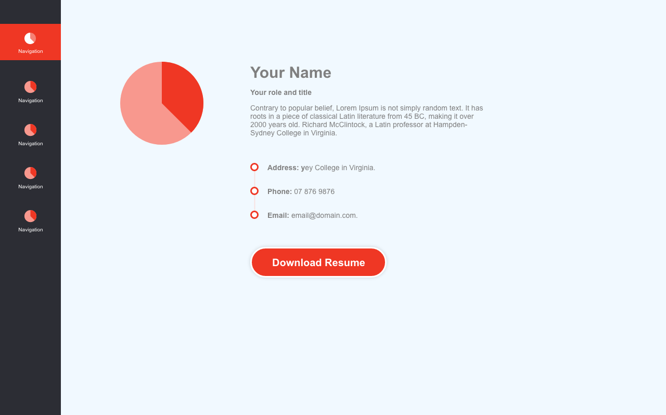

Figure : About Page

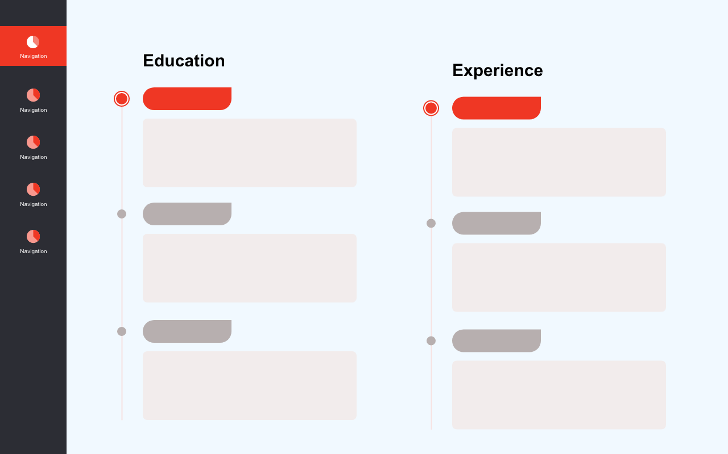

Figure : Academic and Professional Experience

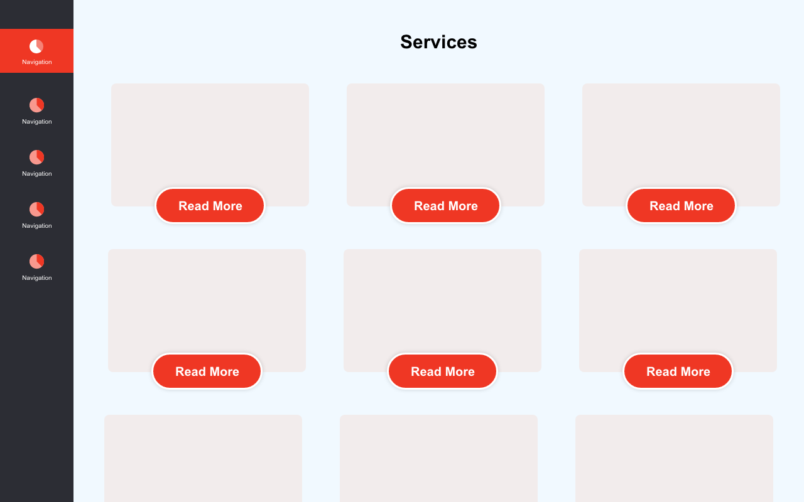

Figure : Services and Skills page

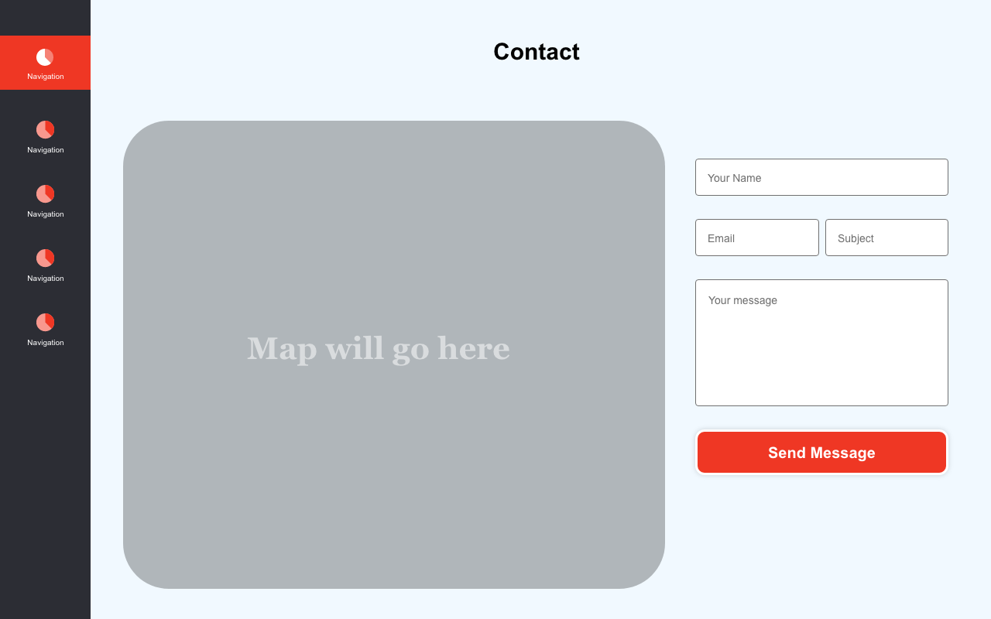

Figure : Contact Page

Figure : Portfolio Page

Figure : Mobile View About Page

Figure : Mobile View Home Page

Figure : Mobile View Experience Page

Figure : Mobile View Education Page

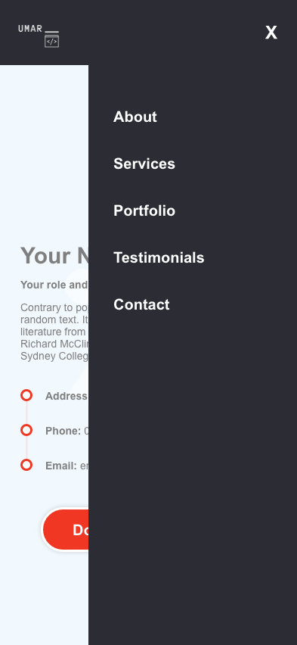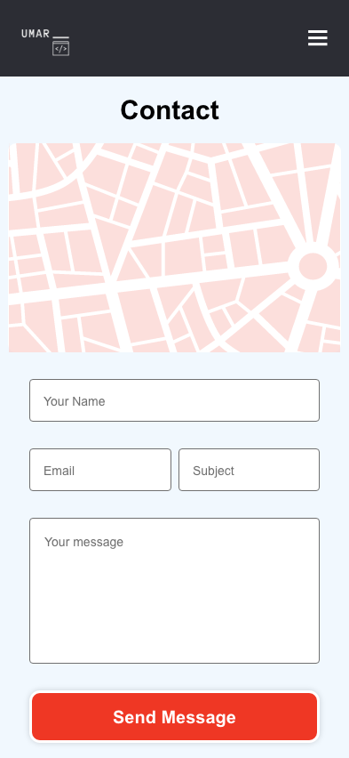

Figure : Mobile View Navigation

Figure : Mobile View Contact Page

# Activity Diagrams

Figure : Activity Diagram Currency Converter

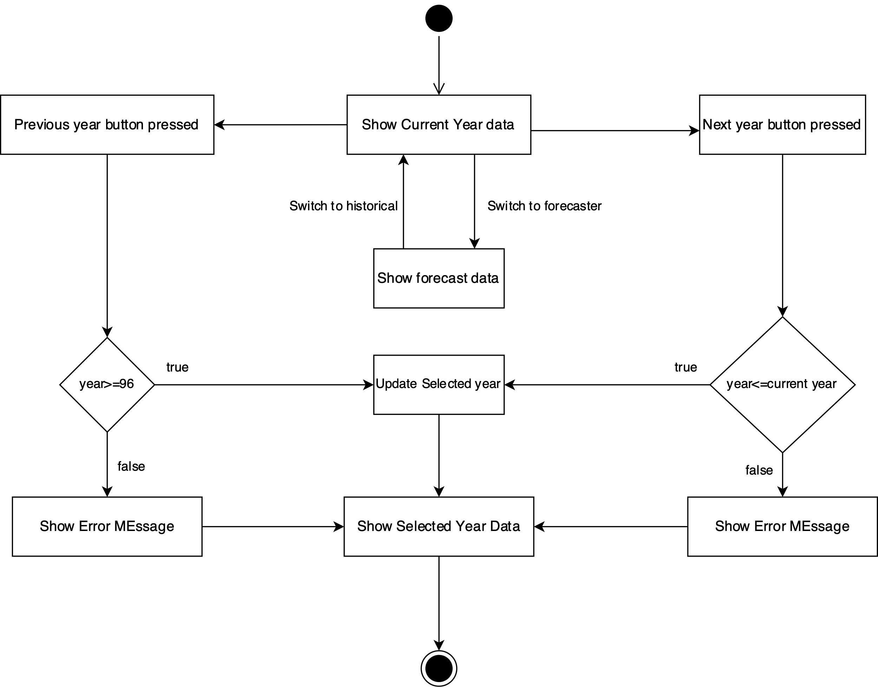

Figure : Activity Diagram Fuel Cost Forecaster

# References

Avouris, N., Tselios, N., Christos, F. & Eleftherios, P., 2003. Website Evaluation: A Usability-Based Perspective.

Anon, 2022. *Web standards..* [Online]   
Available at: https://en.wikipedia.org/wiki?curid=659625\  
[Accessed 12 12 2022].

Dmitriy, n.d. *HTML5 Applications Development Fundamentals 98-375.* [Online]   
Available at: https://docshare.tips/html5-applications-development-fundamentals-98-375_585ea4a6b6d87faea78b6dd1.html  
[Accessed 12 12 2022].

Tanwir, A., Junaid, I., Adnan, A. & Dragos, T., 2019. *Activity Diagrams : A Formal Framework to Model ....* [Online]   
Available at: https://www.researchgate.net/publication/220299018_Activity_Diagrams_A_Formal_Framework_to_Model_Business_Processes_and_Code_Generation  
[Accessed 12 12 2022].

Marianne, 2021. *9 Principles of Good Web Design - read our guidelines to consider.* [Online]   
Available at: https://www.feelingpeaky.com/9-principles-of-good-web-design/  
[Accessed 12 12 2022].